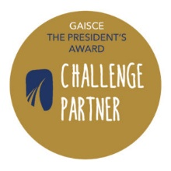
Gaisce’s Challenge Partners
A Gaisce Challenge Partner provides opportunities for participants to meet part of their Gaisce requirements. Below is a list of our current Challenge Partners with a brief explanation of the organisation and how they can support participants to meet Gaisce requirements. Please note that each activity can only be used to meet one of the Gaisce challenge areas i.e. one activity cannot meet both the Personal Skills and the Community Involvement areas.

Our list of Challenge Partners is constantly growing, so check the Gaisce website for up-to-date information (gaisce.ie). Please note, activities do not have to be done in conjunction with Challenge Partners.

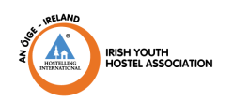
National Challenge Partners
An Óige aim to help young people appreciate the countryside, foster an appreciation of Ireland’s cultural and historical heritage and provides safe, affordable accommodation and travel experiences around Ireland.
HOW: An Óige facilitates Gaisce participants to complete their Adventure Journey by offering low cost, accessible hostel accommodation. They will also offer (where available) the services of a Guide (an experienced and Garda vetted volunteer with knowledge of the surrounding trails and walks) to organisations/groups using An Óige hostels for the Bronze Award. Contact: 01 830 455; info@anoige.ie

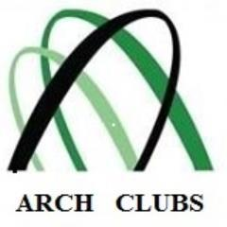
Arch Clubs were established in 1976 to provide a secure, social environment for people with special needs, their siblings and friends to learn, form friendships and above all have fun. At present, there are over 50 community-based social-inclusion-for-all Arch Clubs spread across the country.
HOW: Arch Clubs facilitate Gaisce participants to complete the Community Involvement challenge area by volunteering with a club or becoming an active member of an Arch Club, the Personal Skill area can be achieved through participation in any of the skill based activities in the club and the Physical Recreation area could be met by engaging in sports based activities run by the club. Contact: 01 2951081; archclubs@eircom.net
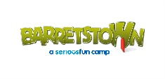
Barretstown offers free, specially designed camps and programmes for children and their families living with a serious illness. It’s recognised as a centre of excellence in childhood cancer care and other serious illnesses. Children are referred based on their medical needs. HOW: Barretstown facilitates Gold Gaisce participants to complete the 5 day, 4 night Residential Project requirement by volunteering in their camps. Contact: Tel: 045 864 115; info@barretstown.org
BT Young Scientist and Technology Exhibition is a project based STEM initiative open to all second level students on the island of Ireland. Individuals or groups of up to three can enter a science based project in the competition.
HOW: BT Young Scientist and Technology Exhibition facilitates Gaisce participants to meet the Personal Skill challenge area by planning, researching, preparing and creating a project. Contact: 1800 924362; youngscientist@bt.com

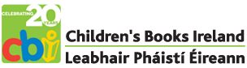
Children’s Books Ireland aims to engage young people in reading and fosters a greater understanding of the importance of books to unlock a passion for literature. HOW: Children’s Books Ireland facilitates Gaisce participants to meet either the Personal Skill or the Community Involvement challenge areas through involvement in their Shadowing Scheme. The Shadowing Scheme and Children’s Choice Award are tangible ways of making young people’s voices heard and offers Gaisce participants the opportunity to make a difference in the lives of young readers as well as developing their own skills in a specific area of interest. Contact: 01 8727475; info@childrensbooksireland.ie
CoderDojo’s vision is a world where every young person has the opportunity to learn code and be creative in a safe and social environment.
HOW: Coderjo facilitates Gaisce participants to meet either the Personal Skill challenge area by developing their coding skills through the programme or could meet the Community Involvement area by voluntarily teaching others how to code. Contact: ross@coderdojo.org
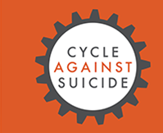
Cycle Against Suicide raises awareness about the issue of suicide, offers reassurance that ‘It’s ok not to feel ok and it’s absolutely ok to ask for help’ and direct people to get help locally and nationally. A two week cycle is organized each year.
HOW: Cycle Against Suicide facilitates Gaisce participants to meet the Community Involvement challenge area by promoting the charity or assisting adult volunteers. Participants can meet the Personal Skill area by getting involved in the Communications (social media, website and promotion), leadership or organisation of events. Participants can also meet the Physical Recreation area by cycling with the aim of taking part in a section of the Cycle Against Suicide cycle. Involvement in the cycle could also meet requirements for an Adventure Journey.
Contact: info@cycleagainstsuicide.com

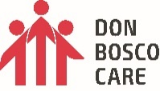
Don Bosco Care works with some of the most at risk people in Ireland and provide residential care, residential aftercare and outreach aftercare for young people who can’t live at home because of violence, neglect or addiction.
HOW: Don Bosco Care facilitates Gaisce participants to meet their Community Involvement challenge area through volunteering with them in general and through involvement in their Don Bosco Cares TY Challenge.
Contact: 01 833 6009; info@donboscocare.ie

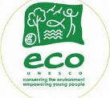
ECO-UNESCO promotes the personal development of young people and raises environmental awareness through practical environmental projects. Their work is based on two simple ideas: "learning by doing" and "thinking globally, acting locally".
HOW: ECO-UNESCO facilitates Gaisce participants to meet the Community Involvement challenge area by involvement in the YEA Action project or the Eco-Community Development QQI Level 3 module. Participants can also meet the Personal Skill area by taking on a specific role within their ECO-UNESCO team e.g. Communications, environmental audit etc. Contact: 01 662 5491; info@ecounesco.ie
Fighting Words provides free tutoring and mentoring in creative writing and related arts to as many children, young adults and adults with special needs. Programmes and workshops are delivered mainly by volunteer writing tutors.
HOW: Fighting Words facilitates Gaisce participants to meet the Personal Skill challenge area by offering the opportunity to develop creative writing skills via their ‘Write Clubs’ (13 – 18 years) Dublin, Dún Laoghaire and Enniskerry. Participants can also meet the Community Involvement area by becoming volunteer tutors.
Contact: 01 8944576; info@fightingwords.ie

Get Ireland Walking is a national initiative that aims to maximise the number of people participating in walking - for health, wellbeing and fitness - throughout Ireland. They aim to promote the benefits of walking and support walking groups and independent walkers.
HOW: Get Ireland Walking facilitates Gaisce participants to meet their Physical Recreation challenge area by supporting them to walk individually and by assisting them to set up walking groups.
Contact: 01 625 1109, info@getirelandwalking.ie
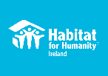
Habitat for Humanity Ireland transforms lives by bringing people together to build homes, communities and hope. Their self-help model provides families and communities with a ‘hand-up’ to pull themselves out of poverty.
HOW: Through their schools programme or the Volunteer Overseas Programme, Habitat for Humanity Ireland facilitates Gaisce participant to meet the Community Involvement challenge area by planning/fundraising/raising awareness and then going on the trip. The trip could also meet the requirements for the Adventure Journey (Exploration) by living in the local community, building with local families and engaging in cultural activities. At Gold Award level, the schools programme and the Volunteer overseas programme can be used for the Residential Project. Contact: 01 531 0033; info@habitatireland.ie

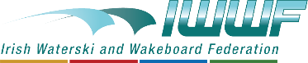
Irish Waterski and Wakeboard Federation (IWWF) is the national governing body for all towed water sports including water skiing, wakeboarding, disabled skiing and barefooting. The mission is to bring the fun of WATERSKI and WAKEBOARD to the attention of all on the island of Ireland and to provide the facilities for them to get involved in a healthy and safe environment for all age groups
HOW: IWWF facilitates Gaisce participants to meet the Physical Recreation challenge area.
Contact: info@irishwwf.ie

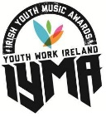
Irish Youth Music Awards (IYMAs) is a flagship programme of Youth Work Ireland. The programme focuses on using music as an educational tool for young people aged from twelve to nineteen years of age and offers them hands on experience learning new skills in the music industry.
HOW: The IYMAs facilitates Gaisce participants to meet the Personal Skills challenge area by involvement in the programme; activities could include: when a song / act is chosen at the Local Live Selection Night, participants of the ‘support team’ volunteer in roles such as social media management or membership of the fundraising team. Contact:
iymas@youthworkireland.ie

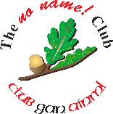
No Name! Clubs are run by, and for young people aged 15-18 years, and enables young members to organise and enjoy positive alternatives to alcohol and drug-centred activities. It increases awareness of the effects of alcohol and drugs, to help young people make informed choices when they are older.They encourage young people could come together and enjoy themselves in a comfortable environment that would be free from alcohol and drugs.
HOW: No Name Clubs facilitates Gaisce participants to meet the Personal Skills challenge area through club membership that enables young people to develop leadership, Communication and organisational skills etc. Young people who volunteer time and effort in attending, running and organising a Club, disco or event can use these activities to meet the Community Involvement requirements of the programme. Contact: 059 6400299, gfleming@nonameclub.ie
Sail Training Ireland involves young people (16 – 30) undertaking voyages on Tall Ships as part of the working crew. Their aim is to make this opportunity available to as many young people in Ireland as possible, particularly those of limited means or with physical or intellectual challenges. The trip allows trainees to experience an adventure and allows them to reach their full potential.
HOW: Sail Training Ireland facilitates young people to meet the Personal Skill challenge area by learning nautical skills. Gaisce participants who volunteer as Youth Mentors could use this to meet the Community Involvement area. The Tall Ships trip could also meet the Adventure Journey or the Residential Project requirements.
Contact: 01 855 9597; info@sailtrainingireland.com

SciFest is a series of one-day science fairs for second-level students hosted in schools and at regional level in third level colleges with a national final each November. The project encourages a love of science, technology, engineering and maths through active, collaborative, inquiry-based learning and provides a forum for students to present and display their scientific investigations.
HOW: SciFest facilitates Gaisce participants to meet the Personal Skill challenge area through involvement in the programme via their science based projects. Gaisce participants, particularly college students involved in supporting a regional coordinator to organise SciFest@College, can use these activities to meet the Community Involvement area. Contact: 086 379 6143; sheila.porter@scifest.ie

Young Saint Vincent de Paul is a youth development programme that encourages and supports young people to engage in positive meaningful volunteering activities within their own communities where they have the opportunity to learn about issues of social justice and work towards creating a fairer and more just society for everyone.
HOW: Young Saint Vincent de Paul facilitates Gaisce participants to meet their Gaisce requirements by volunteering for their Community Involvement or developing Personal Skills by taking on elected roles (e.g.President,Secretary,Treasurer etc.). Contact: 8848233; becca@svp.ie/youth@svp.ie

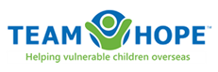
Team Hope Christmas Shoebox Appeal is an Irish, international Christian development aid charity, working with children, and through them, into their families and communities in Eastern Europe, former Soviet Union and Africa. Team Hope is best known for their Christmas Shoebox Appeal, but they also help children all year round through a variety of community development projects, an International Sponsorship Programme and International Volunteer Teams.
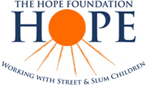
HOW: Team Hope facilitates Gaisce participants to meet their Community Involvement challenge area through involvement in their 13 week TY programme or by getting involved in the organisation and collection of the shoeboxes. Gaisce particpants may choose to use this activity to meet their Personal Skill requirements as it involves organisational skills, time management, Communications and team work etc. Participants could meet their Residential Project requirements by travelling with their faith-based International Volunteer Team. Contact: 01 294 0222; info@teamhope.ie.
The HOPE Foundation works with street and slum children in Kolkata, India who are some of the most disadvantaged children in the world today. They reach out to those most forgotten; offering protection, healthcare, nutrition, education, rehabilitation and a family for life.
HOW: HOPE facilitates Gaisce participants who volunteer with them to meet the Community involvement challenge area through involvement in their School Immersion Programme, Overseas Volunteer Programme, HOPE Volunteers and their Third Level Partnerships. HOPE volunteers could also meet the Personal Skill area through their fundraising, awareness raising, organisational or mentoring/teaching activities. Travelling to Kolkata and volunteering would meet requirements for the Gold Award Residential Project. Contact: 021 4292990; 01 8716930; office@hopefoundation.ie

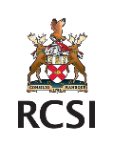
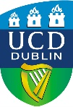
University College Dublin and the Royal College of Surgeons in Ireland are running a ‘citizen science’ project that aims to explore if a tax added to sugar-sweetened drinks might benefit public health. The Irish Government will introduce a tax on sugar-sweetened drinks in 2018 due to evidence that consumption of sugary drinks is linked to conditions such as diabetes, heart disease and obesity. Through this project the team aim to collect data prior to introduction of the tax and then compare with data after the tax has been implemented. This national project will run until 2020 and welcomes input young people from diverse backgrounds and from both rural and urban schools.
HOW: This project facilitates Gaisce participants to meet either the Personal Skill or the Community Involvement challenge area by getting involved in data collection for the project through interaction with local retailers and collecting information on the price and types of products on sale (collection via a bar code scanner on a smartphone) and on the products purchased over a 2-week period. The project will nurture the skills of young people in critical thinking, scientific research, team work, problem solving, communication and leadership while also facilitating youth to play a part in shaping Ireland’s public health policy. Contact: 01-716 4717, 01-402859; gerardine.doyle@ucd.ie; shane.odonnell@ucd.ie; graceomalley@rcsi.ie

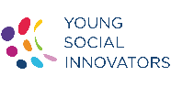
Young Social Innovators (YSI) is a not-for-profit organisation that recognises and celebrates excellence in youth-led innovation and facilitates 12 - 18 year olds to make a positive change in their communities and beyond. YSI programmes promotes social innovation in education, empowers young people to realise their potential and to build their skills and confidence in tackling social issues that face them and their communities.
HOW: YSI facilitates Gaisce participants to meet the Community Involvement challenge area by involvement in any task that a participant does as part of their YSI Action project that enhances either their school or centre or their local, national or international community. YSI team members could meet the Personal Skill area by taking on a specific role within their YSI team (e.g. Communication, organisation, fundraising, budgeting, time management, leadership, photography etc.). Contact: 01 645 8030; admin@youngsocialinnovators.ie

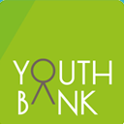
YouthBank is a unique way of involving young people in grant-making within their local community. It is an all-island of Ireland initiative of over 25 grant-making committees run by young people. The funding distributed by these decision-making committees supports projects designed and run by young people that address issues and concerns relevant to them and their community.
HOW: YouthBank facilitates Gaisce participants to meet the Personal Skill challenge area through their involvement in the programme and enhancing skills in leadership, team-work, decision-making, problem-solving, communication, etc. Involvement could also meet the Community Involvement area as they volunteer time and effort into being part of decision-making committees and distribution of funds in their community.
Contact: 086 8101107; edel@iyf.ie

Regional Challenge Partners
Cell EXPLORERS is a science education and outreach programme based in the School of Natural Sciences in the National University of Ireland Galway. They work on a unique model where volunteers and student projects combine to allow sustainable outreach. There are 10 teams running science activities in schools on a voluntary basis. Third level students and employees are involved in public engagement in science.

HOW: Cell EXPLORERS facilitates Gaisce participants to meet the Community Involvement challenge area through their volunteering activities with the group. Region: Galway Contact: cellexplorers@nuigalway.ie

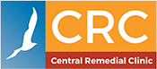
CRC Central Remedial Clinic is committed to working together to make a positive difference to the lives of people with disabilities, their families, and carers. The mission of the CRC is that people with disabilities achieve their potential and live full lives as equal and valued citizens.
HOW: CRC facilitates Gaisce participants to meet the Community Involvement challenge area through their volunteering activities:
- Swimming – supporting adults or children in the water during swimming classes.
- Dining room – serving lunches to children and adults with disabilities and maintaining a clean environment.
- Summer project – during the month of July, they look for volunteers to support children from 7 to 18 years during indoor and outdoor activities and outings.
- Fundraising and other activities Region: Dublin, Limerick, Waterford Contact: www.crc.ie; 01 8542200.

Deaf Communications Ltd. aims to promote Irish Sign Language (ISL) and publish ISL materials, with particular focus on creating an ISL dictionary. They create educational material and resources for children, students and Deaf children. They have created a teaching module for second level students that introduces young people to ISL.
HOW: Deaf Communications Ltd. facilitates Gaisce participants to meet the Personal Skill challenge area for a Bronze Award by completing their 13 weeks Irish Sign Language module. Region: Dublin, possibly surrounding counties. Contact: 086 2573366; pauline.mcmahon100@gmail.com

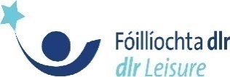
DLR Leisure operate 4 leisure centres in South Dublin in Loughlinstown, Meadowbrook, Ballyogan and Monkstown and provide gyms, swimming pools, fitness studios and all weather pitches. Any surplus money made in DLR Leisure is reinvested in job creation, facility improvements or the provision of new programmes and services.
HOW: DLR Leisure Services facilitates Gaisce participants to meet the Physical Recreation or Personal Skills challenge areas by running a 52 week Gaisce only programme of swimming, Boxercise, Pilates and megamix etc. Participants could use DLR leisure teen gym to prepare for their Adventure Journey. Region: Dun Laoghaire Rathdown area Contact: www.dlrleisure.ie or email doconnor@dlrleisure.ie

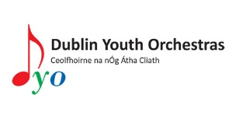
Dublin Youth Orchestra has four orchestras – Junior Strings Orchestra, Intermediate Orchestra, Concert Orchestra and a Symphony Orchestra.
HOW: Dublin Youth Orchestras facilitates Gaisce participants to meet the Personal Skill challenge area through their musical activities in the orchestra. They can also engage in voluntary activities that support DYO in the production of community based concerts by mentoring younger members of the orchestra, event planning, producing promotional material and involvement in community concerts etc. Region: Dublin, Leinster. Contact: 086 8328127; chair@dyo.ie

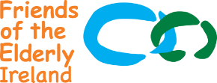
Friends of the Elderly was established in 1980 to bring friendship and companionship to older people living alone or who feel lonely. They take a practical approach to dealing with loneliness and social isolation, alleviating its effects by providing social engagement programmes such as Home Visitation, Friendly Call Service, Social Club and organising Day Trips or Social Events. HOW: Friends of the Elderly facilitates Gaisce participants to meet the Community Involvement or Personal Skill challenge areas by volunteering with members of the elderly community or by supporting the organisation with promotional/fundraising campaigns etc. Region: Dublin Contact: 01 8731855, info@friendsoftheelderly.ie

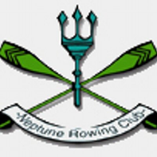
Neptune Rowing Club is one of the largest boat clubs in Ireland. The club is dedicated to promoting the sport of rowing. It’s one of the largest clubs in Ireland and is one of only two clubs in Dublin which is not affiliated to an institution.
HOW: Neptune Rowing Club facilitates Gaisce participants to meet the Physical Recreation challenge area for the Bronze Award by providing a series of rowing lessons for young people through their Junior Rowing programme. Participants may undertake group or individual lessons or may choose to row independently. Gaisce participants could also complete either the Community Involvement or Personal Skill aspect of their award if they volunteer with the club as a volunteer coach. Region: Dublin 7, 8,15. Contact: www.neptunerowingclub.com

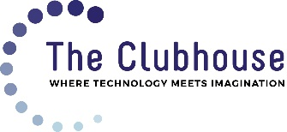
The SWICN Clubhouse in Dublin 8 works with 10 – 18 year olds and teaches them how to use professional software for design, exploration and experimentation. Members can explore professional and academic opportunities and learn from others in their chosen field.
HOW: The SWICN Clubhouse facilitates Gaisce participants to meet their Personal Skill challenge area through engagement with Clubhouse activities and may meet the Community Involvement area by volunteering time to sharing information with attendees. Region: Dublin 8. Contact: 01 4536674; theclubhouse@swicn.ie

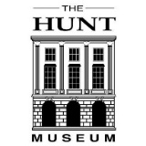
The Hunt Museum preserves and exhibits the original artefacts gathered by John and Gertrude Hunt. The museum displays its own collections, visiting exhibitions with the overall aim of maximizing their cultural and educational potential for the people of Limerick and Ireland.
HOW: The Hunt Museum facilitates Gaisce participants to meet the Personal Skill and the Community Involvement challenge areas by volunteering in the museum in a variety of roles. Region: Limerick. Contact: 061 312 833; info@huntmuseum.com

See gaisce.ie for a full list of all our Challenge Partners.

